**Matchathon event**

**What will be provided for us?**

1. Support in development

2. Potential financing

3. Facilitation of connection with end users (in our case companies looking for this type of database)

**What investors are looking for?**

1. Quick implementation (several months)

2. Gamification

3. Clear pitch

**Project open issues**

1. **How many users reviewing a specific content is enough for our needs?**

We need data to understand the users behaviour. Perhaps consulting with social media companies experts can help us understand this issue more thoroughly.

1. **What is the business plan?**

**Payment per item from the companies**

Social media companies are being heavily criticized for fake new spreading. Therefore, these companies invest a great amount of funds in tackling this issue. For instance, Google recently [announced](https://www.bbc.com/news/business-43473938) a $300m investment in this issue.

FakeMash will serve as a hub for fake news identification, integrating data from various social media channels. FakeMash will be able to provide social media companies with information about their items, which they cannot achieve unless they directly collaborate with each other. This collaboration did not happen until now, probably due to its organizational complexity and business confidentiality aspects.

1. **How do we motivate users?**

Users are keen on changing the world for the best. On the other hand, users don;t want to put too much effort in it. Looking at how many people “protest” by like & share demonstrate this issue. Our marketing massage should therefore emphasize the great contribution to the community by revealing fake news items, and the little effort it takes.

1. **How do we motivate experts? (They gain credibility?)**
   1. Stage A - Social media companies will provide information for free as part of their efforts to fight fake news. In return, they will receive the information about their items.
   2. Stage B - FakeMash will purchase items and the experts reviews them.
2. **How do we get items into our system?**

* Using ML algorithms to crawl the web.
* Creating a tool that will allow the users to rate an item “on the go”, as he/she scroll down his news feed

**What do we need in order to move forward?**

|  |  |
| --- | --- |
| **Task** | **Person in charge** |
| Create a tool that integrates with social media channels. One channel is enough for MVP. |  |
| Create collaboration with social media companies. | Thomas |
| Get an initial amount of users “playing” with the system. |  |
| Create a presentation for the pitch’ showing the magnitude of the problem and the potential of our solution. |  |

Marketing channels:

* our official EUvsVirus site: <https://www.euvsvirus.org/->
* Linkedin page: <https://www.linkedin.com/company/euvsvirus/?viewAsMember=true>
* including the Demo Day: <https://www.linkedin.com/events/6666668119521546240/> -
* and The Matchathon event: <https://www.linkedin.com/events/6666697047430709248/->
* Twitter page: <https://twitter.com/EUvsVirus->
* Instagram page: <https://www.instagram.com/euvsvirus/?hl=ro->
* EuvsVirus Youtube channel: <https://www.youtube.com/channel/UCGp4HTHghLo8gRP_jWMA2TA?view_as=subscriberFacebook>
* page: <https://www.facebook.com/EUvsVirus/->
* Fb events:- Demo Day: <https://www.facebook.com/events/1623634201122719/->
* The Matchathon: <https://www.facebook.com/events/665463977640860/>

@frathgeber / Skill Mentor / Google

@Corbinian / Mentor / Google

@ttimonen / (Skill) Mentor / Google

@Kamil Brzezinski / Mentor / Google

@Kordian Bruck / Skill Mentor / Google

@Simon Johnstone / Skill Mentor / Google

@jernej / Skill Mentor / Google

@sharadkandoi/ Skill Mentor/ Google

@Hoi Lam / Skill Mentor / Google

or these Google Cloud Solution Architects:

@Pradeep Bhadani Skill Mentor

@Ekin

I need to go in few minutes, how we can contact you for: update team members, nationality team members (already communicate to the email mailto:RTD-PAN-EUROPEAN-COVID-HACKATHON@ec.europa.eu) and survey

gleb@fundwise.me (please keep your emails short and don't expect an answer immediately :) ) - pitch coach for “for profit” companies.

<https://ec.europa.eu/info/news/european-commission-hosted-euvsvirus-hackathon-gives-rise-over-2000-pioneering-solutions-fight-outbreak-2020-apr-27_en>

**Matchaton**

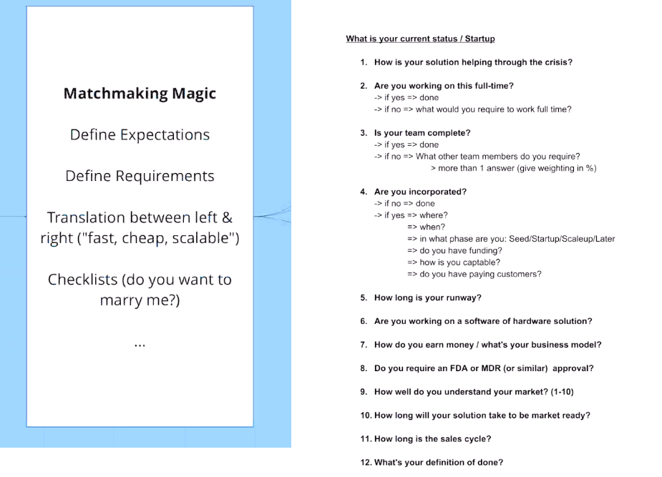

Artem: suggesting to help with Jango, communicating